Manual Instruction

|  |  |
| --- | --- |
|  |  |
| Type: GY4028 Horizontal Pivot Band Saw | |

**NOTE**

Thank you for purchasing our product. Manufactured to a high standard this product will, if used according to these instructions and properly maintained, it might give you years of trouble free performance.

**IMPORTANT:**

**PLEASE READ THESE INSTRUCTIONS CAREFULLY. NOTE THE SAFE OPERATIONAL REQUIREMENTS, WARNINGS & CAUTIONS. USE THE PRODUCT CORRECTLY AND WITH CARE.**

**FOR THE PURPOSE FOR WHICH IT IS INTENDED FAILURE TO DO SO MAY CAUSE DAMAGE AND/OR PERSONAL INJURY AND WILL INVALIDATE THE WARRANTY. PLEASE KEEP INSTRUCTIONS SAFE FOR FUTURE USE.**

**Contents**

[1. DESCRIPTION 1](#_Toc9101)

[2. UNPACKING and ASSEMBLY 2](#_Toc17002)

[3. Installation & ADJUSTMENT 2](#_Toc12884)

[4. OPERATION 4](#_Toc24647)

[5. blade APPLICATION 6](#_Toc29638)

[6. Cooling and lubricating system 6](#_Toc24050)

[7. Maintenance 8](#_Toc31585)

[8. Maintenance of main components 10](#_Toc29036)

[9. trouble shooting 10](#_Toc15798)

[10. Safety 11](#_Toc16716)

[11. APPENDIX 12](#_Toc25117)

2. DESCRIPTION

This type is designed to cut ferrous metal materials., non-ferrous metal, bars and shaped materials. Generally, the hardness of material to cut should be below HRC 35.

|  |  |  |
| --- | --- | --- |
| Power source | | AC 460V 3 phase 60Hz |
| Capacity (Inch) | | ● 11  ■ 8H×15¾W |
| Blade size (Inch) | | 0.035×1×138 |
| Blade speed ( F.P.M.) | | 72.157.229 |
| Motor(HP) | Blade | 3 |
| Hydraulic | 0.56 |
| Coolant | 0.05 |
| Weight (lb) | | Approx.1675 |
| Floor space（L×W×H） | | 71 × 43 × 53 inch |

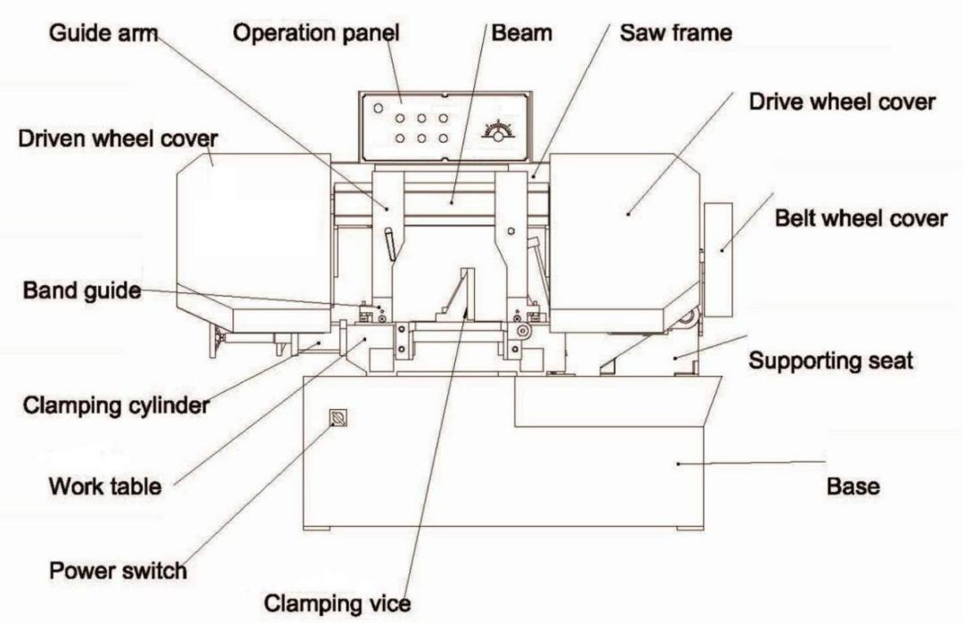

Front view

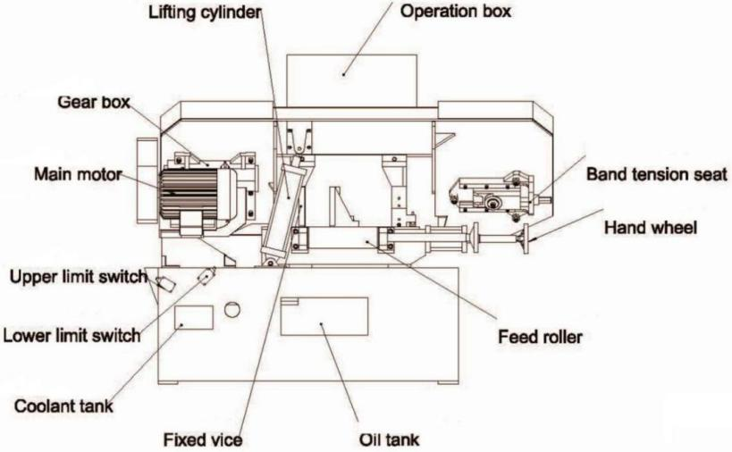

Rear view

1. UNPACKING and ASSEMBLY

2.1 unpacking

2.1.1. Unpack the machine and inspect all parts. If any parts are damaged contact our sale service.

2.1.2. Unbolt from the transport skid and place on a firm, level surface.

2.1.3. Clean all rust protected surfaces with kerosene, diesel oil, or a mild solvent. Do not use cellulose based solvents as these will damage painted surfaces.

2.2 lifting

At lifting with traveling crane, soft matters shall be padded between the band saw machine and lifting rope to protect its painted surface from damage. The lifting rope shall be strong and able to withstand twice weight of the band saw machine and keep lifting balance. Cares shall also be taken to surrounding safety.

2.3Assembly

2.3.1. The machine consists of band saw machine and accessories according to the standard or option, which requires separately lifting and assembling. Please take care while lifting or assembling the machine.

2.3.2 In some cases, the pulley cover might be separated from the band saw machine in transit, it's important to attach the pulley cover with the screws and washers provided. Close when attached and secure with thumb screw.

Uncivilized unpacking shall not be allowed

Warning: At lifting of integral box, cares shall be taken to gravity center to avoid inclination; or injury risk would occur.

**Note**: At unpacking, cares shall be taken to plate and nail to prevent injury. The machine shall be prevented from turn over or damage.

IMPORTANT: ALLWAYS KEEP PROPER FOOTING & BALANCE WHILE MOVING THIS MACHINE!

Use heavy duty fiber belt to lift the machine

1. Installation & ADJUSTMENT

3.1 Work field condition

The machine should be installed in the work field that neither obvious vibration source nor dust or dirty. Flat cement foundation is suggested. Keep machine always out from sun, dust, wet, raining area.

3.2 placement

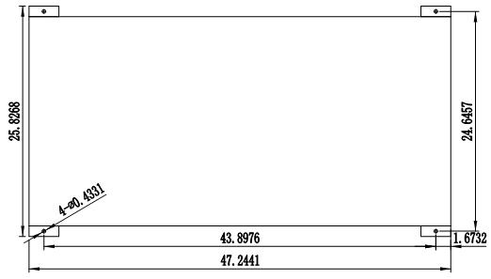There should be enough space around the machine, widen about 1.5 meters and prepare the cement foundation or wood floor, so that it is convenient to install, test or repair the machine. Connect the base of the band saw machine or roller conveyor with foundation bolts, adjust the holes of iron mounts, put the bolts into the foundation reserved holes, fill in the cement paste, assembly till the foundation is dry and solid.

**Note**

3.2.1 Action of feed and discharge: Around the machine there shall be sufficient space for easy feed and storage of discharged pieces.

3.2.2 Maintenance: At maintenance or service, the working personnel likely pass any location of the band saw machine. Hence, one should ensure that when any protection door or distribution panel is opened no interference will occur.

3.2.3 The saw frame fixing plate is used to fix the saw frame in band saw machine (for easy transportation and for protection of saw frame), which hall be removed and well stored after positioning of machine.

3.3 Leveling

Adjust the level with level gauge along the worktable orbital direction longitudinal shift, alternatively moving and leveling, adjust the foundation bolts properly till the machine reaches perfect level, fix them finally.

3.4 CLEANING & LUBRICATING

3.4.1 This machine might have been coated with anti-rust oil to protect in transit, the coating should be completely removed before operating the machine. Commercial degreaser, kerosene or similar solvent may be used to remove the grease, but avoid getting solvent on belts or other rubber parts.

3.4.2 After cleaning, coat all bright work with a light lubricant. Lubricate all moving points with a medium consistency machine oil.

3.4.3 hydraulic oil volume

check level gauge of hydraulic oil tank which is an observer fixed beneath electric box at front right of band saw machine base and is easily readable. In case of insufficient oil volume, replenish L-HM32 hydraulic oil(or some other quality oil) till level 2 divisions above the red mark of the oil level gauge.

3.4.4 Coolant level

Before packing, in order to keep water tank dry, the cooling water of band saw machine is completely discharged.

Immediately before use, cooling water and 5%～8% soap solution shall be added and the cooling water level shall be checked from water level gauge, which is fixed at front left of band saw machine base. During operation, cooling water will constantly flow out.

After completion of daily work, the machine shall be wiped to avoid rust. In case of prolonged shutdown, it shall be coated with anti-rust oil for protection.

Warning: In case of lack of cooling water in water tank, running of cooling water pump shall not be allowed; otherwise it would be damaged.

In case of icing of cooling water in winter, the pump shall not be started. Only after the ice is melted with ca. +10℃ warm water may the pump be started; otherwise the water pump would be damaged.

3.5 connection

**Important:** The voltage fluctuation must be no more than +10%.

Choose the right thickness, kind of the wire for the grounding, according to the capacity of the main protector, the way and length of wiring.

Either the power or grounding is forbidden to share with any welding machine, so as to avoid any o damage to the machine or accidents.

3.5.1 Any distribution job shall be carried out by electricians in accordance with state distribution standards.

3.5.2 TURN OFF power before wiring, and be sure the machine in proper grounding. Overload & circuit breaker is recommended for safety wiring.

3.5.3 The connection of power source in the machine (if necessary) shall be made with proper cable which shall be adaptable to

the voltage used in the machine.

3.5.4 Take off the cover plate of the electrical box. Lead the cable from the general power into the power entrance.

3.5.5 Connect the cable separately with terminal blocks L1, L2 and L3(Refer to red line L1-3 from the figure), connect the ground wire with the terminal PE. Cover the plate of the electrical box.

3.5.6 After connection of power source, electrical devices shall be turned on.

After connection of proper power source, it's important to check the main power source for correct connection.

3.5.7 Turn on the power switch on the left to the oil tank to (1) position, the indicator on the control panel lights on. Turning off the power switch to (0) position will cut off the power source or urgently stop the machine. Avoid power off during operation work, or unexpected damage might occur to the machine. Check carefully if the saw blade is running in counter-clockwise direction or not, reverse the wiring per circuit diagram then repeat the running test.

3.5.9 After pressing “Frame up” button, the saw frame will be lifted; otherwise, the main power source shall be checked for correct connection as per procedure 3.5.5-3.5.6.

3.5.10 Turn off the power switch. Cut off the power source. Exchange any two terminals of power source and retry.

4. OPERATION

WARNING! Before operating the bandsaw ensure that you read, understand and apply the safety instructions

**4.1 CONTROL PANEL**

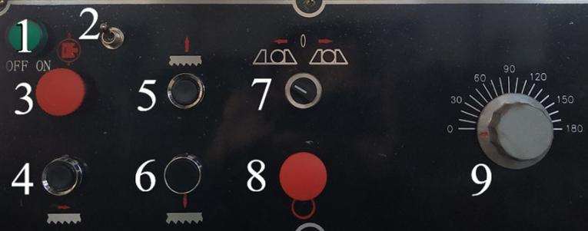 **10** 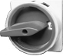

|  |  |  |
| --- | --- | --- |
| **No.** | **Switch** | **Function** |
| 1 | Indicator | After switching on the power supply, the indication lamp lights on |
| 2 | Lamp knob | The default set to off, the opposite is on. |
| 3 | Emergency stop &  hydraulic Start/Stop) | Rotate it to main stop the saw for critical situation.  Press it to to start the hydraulic, press again to stop the hydraulic |
| 4 | Blade Run | After pressing it, the blade motor started, saw wheel rotates and indicator lights on |
| 5 | Frame up | Pressing it to lift the saw frame, while releasing it will stop. When it reaches the upper limit , it will stop. |
| 6 | Frame down | Pressing it to lower the saw frame normally, while releasing it will stop. When it reaches the lower limit , it will stop. |
| 7 | Vise loosing / clamping | Turn it left to loose the material, right to clamp. |
| 8 | Blade stop | After pressing it, the blade motor stopped, saw wheel stops and indicator lights off. |
| 9 | Speed control valve | Turn clockwise to increase the speed, anticlockwise to lower. |
| 10 | Power switch | Turn to (1) position to start, (0) position to stop |

4.2 Preoperation

**Note**. It is important that these instructions are followed carefully in order that the saw is started safely and correctly.

Take material within the cutting capacity to test

Select the speed of feeding and cutting, please reduce the certain speed to half for the first piece, and observe the cutting process. When it works well, gradually increase the speed.

Please open the hydraulic pump and check the pressure, if necessary, adjust it to the standard.

1. Make sure the blade is suitable for the material to cut. Take the saw blade provided or select a proper saw blade, please consider the type, shape and spec of the material to cut.
2. Fix the saw blade. Please make sure there’s a little clearance between the back of saw blade and the rim of the saw wheel.

Tension the blade properly.

(3) Check the blade for correct tension and check the blade guide bearings. Make sure the blade guide arm is adjusted as close as possible to the material to cut.

(4) Fill up the tank with hydraulic oil, cooling fluid.

(5) Turn on the main switch of power. Start the hydraulic, try every actions and check if there’s any oil spills, run it without any cutting action about 15 minutes. If there is any abnormal occurrence, go to chapter of trouble shooting to work out, if you encounter serious problem, please stop the saw at once and contact with our sales service in time. Run again after solving the problem.

(6) Lower saw frame(No.6), adjust the cutting size accordingly. Then, lift the saw frame. (No.5)

(7) Place the material between the vises, adjust it for the desired length of cut. Then, clamp the material to be cut (No.7)

(8) Lower saw frame (No.6) till the it is about 2 inches to the material. Set the upper limit position switch.

(9) Start the saw blades((No.4). Adjust the coolant flow. Observe the cutting process especially for the first piece, if there is any abnormal occurrence, please raise the saw frame(No.5). Start again after resolving the problem.

(10) When the cutting finished, the lower limit position switch will retract automatically, please adjust the high limit position switch and stop the saw. Check the length of the work piece, if necessary, check again after the second piece finished.

4.3 Notes for operation

(1) The new saw blade shall be sharpened before use.

(2) Before connecting the machine to an electrical power system, be sure the motor rating agrees with the electrical system it is to be connected. Make sure the voltage class of the saw is the same as that of end user in the local area. We recommend that # 14 wire, fused with a 16 amp, dual element, time lag fuse, be used to supply power to all machines regardless of their electrical rating. Refer to the electrical schematic supplied with the machine for instructions on how to connect the machine to the power source.

(3) The saw lowering speed is adjusted with the cutting speed adjustment valve, which shall be comprehensively considered on the basis of hardness and size of material and the saw blade speed.

(4) It adopts two four-way solenoid valves to control the actions of vises, clamping or loosing. Once the hydraulic pump starts up, the pressure oil goes straightly through clamping cylinder rod-less cavity, if the vise is in loose state, hydraulic pressure will push the vise to move rightwards, and act clamping. Please take care!

(5) Check the shape of chips to judge if the speed of saw blades is appropriate with the sawing. If necessary, make the adjustment.

Tips: Thin or powdered chips: to increase feed rate or reduce blade speed

Burned heavy chips: to reduce feed rate and or blade speed.

Curly silvery and warm chips: optimum feed rate and blade speed

(6) After completion of daily work, move out the material and lower the saw frame to the lowest position.

4.4 Notes to related devices

1. **Wire brush** The wire brush is fixed in the adjustable cover and during work the saw blade will pass through the wire brush, thereby the iron chips on it will be automatically cleared off. The top of wire brush is fixed with a knurled handle, which may lock and fix the wire brush. After releasing wire brush unit, the wire brush or saw blade may be replaced.

**Important!** When the margin of wire brush safely contacts but doesn't exceed the saw teeth, the wire brush is properly installed.

**Warning!** It's important to disconnect the saw from the power source and wear gloves before replacement.

**(2) Hydraulic oil level gauge** The hydraulic oil is important medium fed to hydraulic system for the normal working and the operator shall frequently watch the indication of the oil level gauge.

The hydraulic oil level shall be 2 divisions above the red mark and when the level is lower than the said value the oil shall be replenished; otherwise the hydraulic system would be unable to work and hydraulic elements would be damaged.

**Oil level gauge of gear box** The gear oil is important medium fed to power system for the normal working and the operator shall frequently watch the indication of the oil level gauge. The gear oil shall be kept at middle of red mark and when the level is lower than the said value the oil shall be replenished; otherwise the hydraulic system would be unable to work and the important components of gear box would be damaged.

5. blade APPLICATION

CAUTION: BLADE TEETH ARE SHARP, HANDLE WITH CARE.

It is important to choose the suitable band saw blades and the cutting method. We suggest the saw user to take the required cutting condition of material into careful consideration before your choice, such as cutting precision, cutting speed and cutting cost, safety management, and so on.

5.1 selection

The tooth form, tooth pitch of the blades as well as type of that varies with the material, shape, size and fixation methods adopted. Besides, given the same material to cut, various saw blades used for different cutting conditions, such as the cutting precision, cutting speed and cutting cost. Please consult it with our sales service and choose the suitable one.

5.2 Installation

1. Hang the saw blade onto the driving wheel and passive wheel and through the upper blade guide, working all the way up between the blade guide bearings with the back of the blade against the back-up bearings.
2. Put light tension on the blade and work onto both wheels, ensure the back of the blade is against the flanges of both wheels.
3. Adjust blade to the final tension. Proper tension is achieved when the pointer is on the left mark of the blade tension scale behind the idle wheel.
4. Release the wire brush locking unit to lift the wire brush to make it cover the saw teeth.
5. Adjust the height of wire brush to make it just contact bottom of saw teeth.
6. Connect the saw to the power source and turn it on and off about two or three times to ensure the blade is seated and tracking properly. When finished close the wheel covers.

5.3 Replacement

1. Disconnect the saw from the power source.
2. Raise the saw frame about 5.9”.
3. Slide the left blade guide arm to the right as far as it will go.
4. Open both wheel covers and clean chips out of the saw.
5. Release blade tension by unscrewing the blade tightening handle
6. Remove the blade from both wheels and out of the blade guides.
7. Make sure the teeth of the new blade are pointing in the right direction (teeth pointing down).
8. Place the blade on the wheels, in the blade guides and adjust it, then tension the blade.

6. Cooling and lubricating system

6.1 cooling system

It includes the coolant pump, pipeline, joint, tap and cooling pool. The use of proper cutting fluid is essential to obtain maximum efficiency from a band saw blade. The main cause of tooth failure is excessive heat build-up. This is the reason that cutting fluid is necessary for long blade life and high cutting rates. Cutting area and blade wheels should be kept clean at all time. The rate of coolant flow is controlled by the tap.

**Tips:**(1) Lubricate the moving parts before or after running the saw, such as the column guide rail, the worm gear, the lead screw

under the vises, the slanting-roll lead screw and so on. It’s necessary to lubricate the saw every workday.

1. After 3 months of working, it’s necessary to clean the hydraulic oil tank replace the hydraulic oil and the lubricating oil for the bearing of the pulley.

**Lubricating reference**

|  |  |  |  |  |
| --- | --- | --- | --- | --- |
| No. | Position | Type of oil | Cycle(per shift) | Method |
| 1 | bearing of the pulley | grease | once | oil gun |
| 2 | bearing below the lifting cylinder | grease | once | oil gun |
| 3 | guide rail of the tension device | grease | once | oil gun |
| 4 | guide head | grease | once | oil gun |
| 5 | bearing above the worm gear box | grease | once | oil gun |
| 6 | rolling bearing of the guide device | engine oil | once | oil can |
| 7 | lead screw and the sliding surface of the movable vise | engine oil | once | oil can |
| 8 | worm gear box | hypoid gear oil | once | Oil bath |
| 9 | axle of the lifting or lowering of the saw frame | engine oil | repeatedly | oil cup |

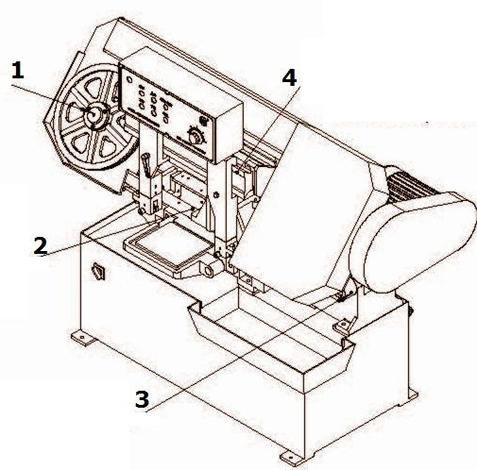 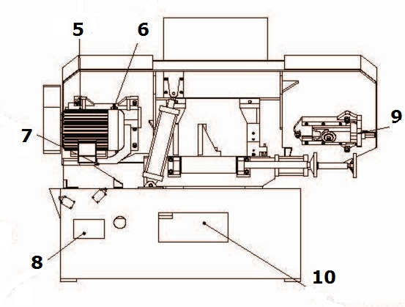

**Tips:**

No.1 Molybdenum disulfide lithium-base grease from oil hole of worm shaft, added weekly

No.2 Molybdenum disulfide lithium-base grease from the guide rail of vise, added weekly

No.3 Machine oil from the oil hole of support axis, every day

No.4 Molybdenum disulfide lithium-base grease from the beam, added weekly.Tips:No.5 Molybdenum disulfide lithium-base grease from oil hole of worm shaft, added weekly

No.6 Special for worm shaft from the oil hole, changed after 1 month of new machine, changed every 6 months after that

No.7 Oil drain to worm box

No.8 Clearing cooling fluid to the coolant tank, added every day

No.9 Molybdenum disulfide lithium-base grease from the screw rod for tightening, added per week

No.10 Hydraulic oil changed every 5 years from hydraulic tank

**Fluid related**

1. **Hydraulic oil**

If you start the pump without enough hydraulic oil, the pump and motor would be damaged, please make sure that there is enough hydraulic oil before starting the saw.

Make sure the level of hydraulic oil reach the middle of the oil level . If not, add oil through the oil filler.

Please use quality anti-wear hydraulic oil, such as L-HM32

Change the hydraulic oil once a year.

**Temperature Limit of Hydraulic oil**

15-0℃: **Low** High-viscosity if it's below 15℃

30-20℃: **PropeR** Suggested 20℃, highest performance, longest operating time enabled

55-30℃: **Available**

80- 55℃: **limited** operating time shortened, requires oil cooler. As it rises by 8℃, the time shortened by half.

100- 80℃: **dangerous** Forbidden!

1. **Cutting fluid**

If you start the pump without enough cutting fluid, the pump and the motor would be damaged. Make sure that cutting fluid is enough before saw started. The cooling fluid added to the cutting fluid tank upside the chips tank.

The ratio of cutting fluid dilution with water about 1:20, adjusted according to the processing requirement.

The cutting fluid should be changed at least once per 6 months, the cooling system cleaned as well .

1. **Gear oil**

Make sure that the oil level is between the up and down limit. If not, the gear oil should be filled up to the proper level.

The gear oil should be changed once per year, or after the first 300 hours of using from the gear box.

1. Maintenance

WARNING! Before carrying out any maintenance ensure that the machine is switched off, isolated from the mains supply and that the blade is at a complete standstill. Failure to comply with this instruction can cause serious injury.

**WARNING!** Before carrying out any maintenance ensure that the machine is switched off, isolated from the mains supply and that the blade is at a complete standstill. Failure to comply with this instruction can cause serious injury.

7.1 checking points

(1) The position of wire brush to ensure thorough clearing off chips from teeth groove, and, if necessary, adjust or replace the wire brush. Check its height to make it just contact with but not exceed the bottom of saw teeth to avoid excessive wearing out of

saw blade or wire brush.

(2) The indication of gear box and hydraulic oil level gauge, replenish gear oil or hydraulic oil, in case of oil shortage

1. The indication of cooling water level gauge to decide replenishing or not.
2. Correct position of the saw blade from the driving, passive wheel and the blade guides.
3. The saw blade tension state
4. The gear box tension belt.
5. Clearing the chips from driving and passive wheel for new saw blade installation

7.2 Cleaning and replacement

**7.2.1 General cleaning**

WARNING! Do not use compressed air to clean the saw as metal filings may blow into the blade guide bearings and other critical areas. Dangerous while the flying particles released into the surrounding area.

Keep all surfaces clean and free of rust, chips, and coolant build-up. After completion of daily work, the saw shall be cleaned and wiped. Use a small paint brush or parts cleaning brush to remove metal particles. If inaccessible (and ferrous) use a magnetic pick-up tool. Regularly wipe the saw down with a clean dry cloth and protect all unpainted surfaces with light machine oil.

Keep blade guides clean and free of metal filings.

**7.2.2 Replacement of wire brush**

Important!

Incorrect installation of wire brush would result in excessive wearing out of wire brush or instable cutting.

Proceed as follows:

a. Turn off the power switch. Release knurled handle and wire brush unit

b. Loose the wire brush set nut on the driving spindle and take out the wire brush

C. Fix new wire brush and fix it with nut. The top of the wire of the fixed wire brush shall safely contact with but not exceed the

tooth of the saw blade and then the brush is locked

**7.2.3 Replacement of cooling water**

Under normal use, the cooling fluid shall be replaced and chips shall be cleared off from water tank every 3 months. Proceed as follows:

a. Turn off the power switch. Open the sealing plug of the water tank to dry the cooling fluid, and refix the sealing plug

b. Take out filter net cover

c. Clear the chips from the water tank, and wipe it with cotton cloth

d. Fill the tank with cooling fluid and running water

**7.2.4 Replacement of hydraulic oil**

The hydraulic oil shall be replaced every 5 years. Proceed as follows:

a. Turn off the power switch. Take out hydraulic oil drain plug from saw bottom and make hydraulic oil flow to proper container.

***Note****:* The hydraulic oil may be pumped from oil tank to another container as anti-rust oil.

When the oil tank is emptied, it shall be cleaned with the same type of clean hydraulic oil, and it can’t be cleaned with kerosene. It may be cleaned with hot oil (80℃), in this case effective oil filter shall be fixed and all elements shall simultaneously work.

b. Inject the L-HM32 hydraulic oil into the oil tank through filter, till it approaches 2 divisions above the red mark.

Wipe anywhere might be dropped with hydraulic oil.

**7.2.5 Replacement of gear oil**

After every 6 months or 1200 hours the gear oil shall be replaced. Proceed as follows:

1. Turn off the power switch. Open oil drain plug of gear box, discharge gear oil, re-fix the oil drain after that
2. Open oil-filling plug. Inject the new gear oil till it approaches 2 divisions above the red mark on the oil level gauge.
3. Fix oil-filling plug

**7.2.6 Oil cup on slide sleeve**

Daily fill oil cup with machine oil, and adjust nut of the oil cup to make oil evenly lubricate vertical main tube.

7.3 Notes to daily work

(1) Before starting the machine, lubricate the moving parts, including the guide rail, the bearings, and so on. Please clean the hydraulic oil pool, replace the oil according to the requirement of the lubricating system.

(2) If you would like to run the machine, please start the hydraulic system first, then Operate without any cutting action. If everything works well, you can start cutting.

(3) loosen the band saw blades after working so as to extend the service life.

(4) Put the material away from the machine, clear the chips or other things for the machine. Wipe up the coolant liquid of the worktable and the guide rail. Finally, lower the saw frame to the lowest position.

(5) Cut off the power in case of any accidents before getting off work.

(6 )Please plan an overhaul for the machine every three years.

(7) Reference: Bearings

|  |  |  |  |
| --- | --- | --- | --- |
| Model | Type | Qty. (pcs ) | Location |
| 628 | deep groove ball bearing | 4 | end of guide block |
| 6206 | deep groove ball bearing | 2 | Roller of infeed supporting |
| 6207 | deep groove ball bearing | 1 | Worm |
| 30306 | taper roller bearing | 2 | Worm |
| 30211 | taper roller bearing | 2 | Worm wheel |
| NJ207E | cylindrical roller bearing | 2 | Passive wheel |
| 51104 | thrust ball bearing | 1 | Tension screw rod |

8. Maintenance of main components

**Main driving system**

It is made up of blade motor, worm gear box, the driving pulley system, and the passive pulley system. The machine gains 3-step speed through the triangle belt.

**Hydraulic system**

It is made up of the oil pump, the electrical motor, the solenoid valve, the flow control valve, the cylinder, the oil tank, the pipeline. (Refer to the appendix)

**Electrical system**

It is made up of the main motor, the hydraulic motor, the cooling motor , the position switch, the distribution box , the operation panel, the lamp, electrical elements, cable and so on. (Refer to the appendix)

**9.** trouble shooting

|  |  |  |
| --- | --- | --- |
| **Problem** | **Causes** | **Solution** |
| The saw blade falls | 1.the blade is loose.  2.the passive pulley is not parallel | 1.tension the blade properly.  2.adjust the 3 groups of screws behind the passive pulley to locate the blade. |
| Strange noise from the worm gear box | 1.the axial clearance between the worm wheel and worm is large.  2.two pairs of bearings worn out. | 1.lessen the axial clearance  2.replace the bearings. |
| saw frame lifting /up failure | 1.the oil pressure is low.  2.the related valve for lifting broken.  3.the upper limit position switch is reset or not.  4.the oil pipe draws in air or locked. | 1.check, adjust the pressure  2.check the circuit, pipeline.  3.check the position switch.  4.clean, change the filter, valve related . |
| saw frame lowering/down failure | 1.the flow control valve is blocked.  2.the valve related for lowering broken  3.the lower limit position switch is reset  4. Excessive back pressure | 1.check, clean the flow control valve.  2.check the circuit, pipeline.  3.check the lower limit position switch.  4.lower the pressure |
| saw frame shaking or making strange noise during cutting | 1.the gap between the column and the sliding bush is large.  2.the speed is not suitable.  3.the gap between the blade and the guide blocks is large. | 1.replace the bush.  2. adjust the speed.  3. adjust the guide blocks. |
| Serious deviation of the work piece | 1.high speed of cutting  2.passivated saw teeth or the dividing is asymmetric  3.space of the two guide arms is large  4.the blade is not well tensioned  5.guide blocks are not well adjusted  6.the band of blade is not vertical to the work table or the fixed vise. | 1.reduce the speed  2.replace the blade  3.lessen the space  4.tension the blade  5.adjust the guide blocks  6.adjust the guide arms to suit the band |
| Power switch is on, but indicator unlit | 1.the power is lack of phase.  2.the fuse is broken. | 1.check the main power circuit.  2.replace the fuse. |
| Noise from oil pump | the filter net is blocked or the oil is badly absorbed | Clean the filter net |
| Hydraulic oil goes foamy | 1.the oil is not enough.  2.the inlet pipe leaks.  3.the return pipe is above the surface of oil. | 1.add the oil.  2.repair the pipe.  3.lower the return pipe. |

1. **Safety**

10.1 Safety rules

1. Wear tight clothes, anti-slip footwear. Don’t wear gloves when operating.
2. The power source voltage must not exceed +10% of the electrical equipment voltage
3. The relative position of two guide arms and the movable vise should be adjusted to avoid any collision
4. Cut off the power before carried out any repairing or maintenance to the machine.
5. Don’t operate the machine on assumptions, or being absent-minded
6. Don’t start cutting until the work piece being tightly clamped. Use special fixture for irregular materials clamping.
7. Take anti-down measures for thin, short material cutting, or the work piece might fall down, rolls out, and cause danger.
8. Place some roller table in the front and rear to the machine while cutting long material, or the work piece might fall down and cause danger while being cutting or cutting finished.
9. Forbidden to operate the machine when the belt cover is open or taken off.
10. When the blade is running, don’t adjust the wire brush or clear the chips, so as to avoid any danger
11. Stop the machine before do the cleaning, otherwise, part of your body or the tool might be involved in and cause danger.
12. It’s dangerous to stand on the feeding rack, or you might fall down.
13. Water-soluble cutting liquid adopted, so the oily liquid might cause smoking or fire during cutting. There

should be a fire extinguisher in the vicinity of the machine as well as a fire alarm. The machine must not be left operating.

1. Don’t touch the blades when it is running, otherwise, your hands might be involved into the machine.
2. Don’t cut carbon rod on this machine, or the chip will reduce to powder, send into the air, and make the air into combustible qualitative. If it meet the electric arcs, electric spark arise fire sparkles, caused by the running motors of the machine, it will catch fire or explode. Special measures must be carried out while cutting materials like carbon rod.

9.2 Warning signs

Follow the rules mentioned for the symbols and signs, keep them legible, if damaged, restore them to their original state.

|  |  |
| --- | --- |
| **Label** | **Note** |
| wps_clip_image-24499 | Read and understand the instruction manual before operating the machine. Work only with protective gloves. |
| wps_clip_image-21743 | Don't open the shields during the machine operation |
| wps_clip_image-2117 | Keep arms, hands, and fingers away from the saw blade. |
| wps_clip_image-3794 | Avoid awkward operations and hand positions. |
| wps_clip_image-19565 | Never leave the machine running unattended. Turn the power off. Any splashing oil or titanium magnesium chip may cause fire, especially materials like carbon rod. |
| wps_clip_image-18188 | Dangerous! Risk of serious injury. Turn the machine ''OFF'' and disconnect the machine from the power source before maintenance. |
| wps_clip_image-1871 | 1.Clean the machine once a day, add oil to the sliding contact part. Add the butter to the nozzles once a month.  2.Change the cutting fluids and clean the cooling system every six months. 3.Change the hydraulic oil with high quality once a year. 4.Change the gear oil once a year. Change the oil after the first 300 hours of using the worm gear box. |

1. **APPENDIX**

**Hydraulic drawing, schematic sheet and part list**

|  |  |  |
| --- | --- | --- |
| **Name** | **Model** | **Qty.(pcs)** |
| Filter net | WU3-Z160×160F-S | 1 |
| Relief valve | P-B10B | 1 |
| Gear pump | CB-B4 | 1 |
| Manometer | Y-60 | 1 |
| [Solenoid](C:/Documents%20and%20Settings/Administrator/Local%20Settings/Application%20Data/Yodao/DeskDict/frame/20140808204841/javascript:void(0);) valve | DSG-02-2B11B DL | 1 |
| [Solenoid](C:/Documents%20and%20Settings/Administrator/Local%20Settings/Application%20Data/Yodao/DeskDict/frame/20140808204841/javascript:void(0);) valve | DSG-02-3C211B DL | 1 |
| [Solenoid](C:/Documents%20and%20Settings/Administrator/Local%20Settings/Application%20Data/Yodao/DeskDict/frame/20140808204841/javascript:void(0);) valve | DSG-02-2B2 DL | 1 |
| Speed control valve | L-10 | 1 |
| Hydraulic motor  Cylinder for the saw frame for the vise | 0.42KW |  |

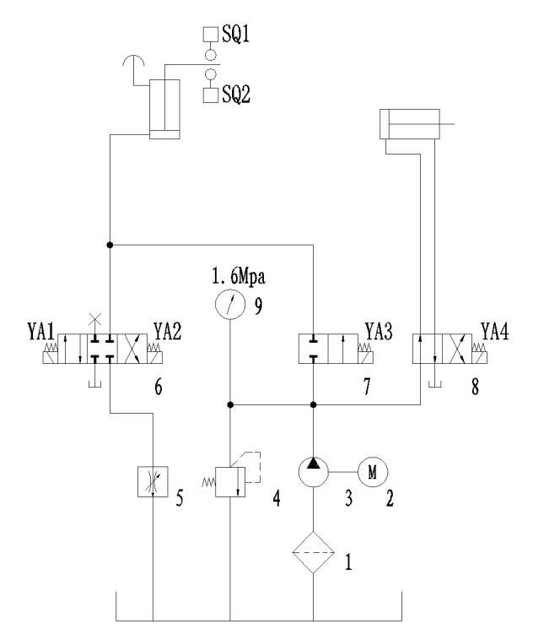

|  |  |  |  |  |  |
| --- | --- | --- | --- | --- | --- |
| Electromagnet | Saw frame | | | vises | |
| Up | Down | feed | Close | Open |
| YA1 | **-** |  | **+** |  |  |
| YA2 | **-** | **+** |  |  |  |
| YA3 | **+** |  | **-** |  |  |
| YA4 |  |  |  |  | **+** |

**Electrical schematic drawing, part list**

**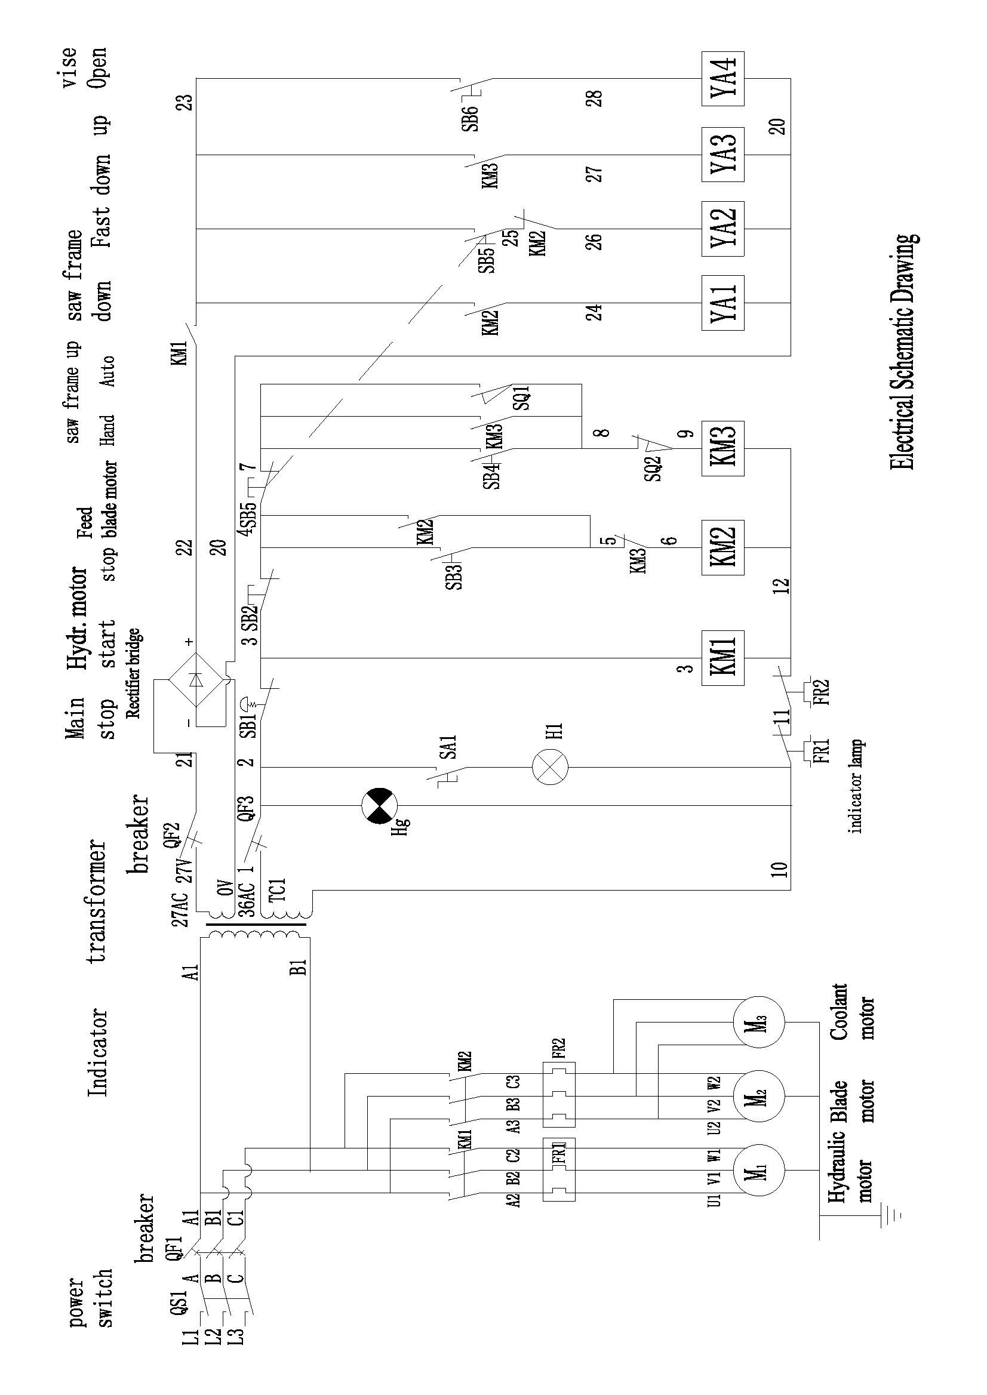**

|  |  |  |
| --- | --- | --- |
| **Name** | **Model** | **Qty.(pcs)** |
| Blade motor | 2.2kw | 1 |
| Coolant motor | 0.04kw | 1 |
| Transformer | BK-150 | 1 |
| AC contactor | AC36V CJX-120 | 2 |
| AC contactor | AC36V JZC4-22 | 1 |
| thermal overload relay | JR36-20 2.4A | 1 |
| thermal overload relay | JR36-20 7.2A | 1 |
| Breaker | DZ47-60/C20 3P | 1 |
| Breaker | DZ47-60/C5 1P | 2 |
| Emergency stop button | LAY3-11 | 1 |
| Knob button | Φ22LAY3-11X/21 | 1 |
| Button | Φ22LAY3/11A | 3 |
| Lamp | JC34 24V | 1 |
| Indicator | XD1-25/40 | 1 |
| position switch | YBLX-K1/411（5A） | 2 |
| Terminal block | TB-2512L | 2 |
| Terminal block | TB-2504L | 1 |
| Rectifier bridge | MDA8635 | 1 |

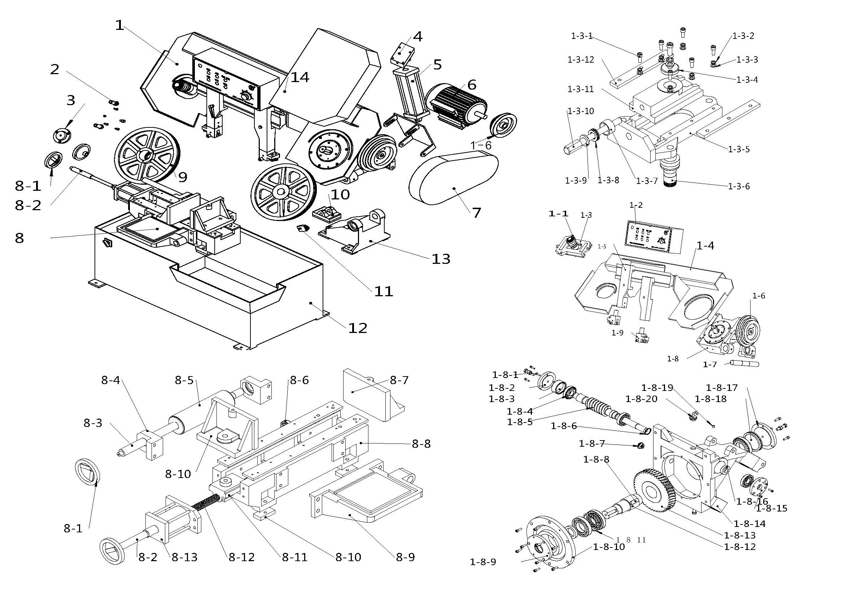







**Partial detail of band saw figure**

|  |  |  |  |
| --- | --- | --- | --- |
| **Fig. No.** | **Part name** | **Fig. No.** | **Part name** |
| 1 | Saw wheel | 1-1 | bearing |
| 2 | Nut | 1-2 | Electric box |
| 3 | Top Cover of driven saw wheel | 1-3 | **Band tightening seat** |
| 4 | Top seat of hydraulic cylinder | 1-4 | Beam |
| 5 | Hydraulic cylinder for frame up/down | 1-5 | Band guide arm |
| 6 | Blade motor | 1-6 | Belt pulley |
| 7 | Cover of belt pulley | 1-7 | Support seat |
| 8 | **Vise set** | 1-8 | **Worm gear box** |
| 9 | Saw wheel | 1-9 | Band guide head |
| 10 | Seat of hydraulic cylinder | 1-3-1 | nut |
| 11 | Position switch | 1-3-2 | Spring shim |
| 12 | Base | 1-3-3 | Flat shim |
| 13 | Support seat | 1-3-4 | Big flat shim |
| 14 | Cover of driven saw wheel | 1-3-5 | Band tighten seat |
| 1-8-1 | Nut | 1-3-6 | Axis of driven saw wheel |
| 1-8-2 | Top cover to worm shaft | 1-3-7 | Bearing housing |
| 1-8-3 | Adjusting shim to worm shaft | 1-3-8 | Plane bearing |
| 1-8-4 | Bearing | 1-3-9 | Flat shim |
| 1-8-5 | Worm shaft | 1-3-10 | Screw rod for tightening |
| 1-8-6 | circlip | 1-3-11 | Sliding block |
| 1-8-7 | oil leveler | 1-3-12 | Layering |
| 1-8-8 | Flat key | 8-1 | Hand wheel |
| 1-8-9 | Oil seal seat to worm gear | 8-2 | Extension bar |
| 1-8-10 | Flange | 8-3 | Feeding axis |
| 1-8-11 | Bearing | 8-4 | Angled bearing seat |
| 1-8-12 | Axis of worm gear | 8-5 | Feeding roller |
| 1-8-13 | Worm gear | 8-6 | bearing |
| 1-8-14 | Worm gear box | 8-7 | Fixed vise |
| 1-8-15 | Oil seal seat to worm shaft | 8-8 | Vise body |
| 1-8-16 | Oil seal | 8-9 | Receiving plate |
| 1-8-17 | Top cover to worm gear | 8-10 | Vise body cushion |
| 1-8-18 | Adjusting shim to worm gear | 8-11 | Sliding block for clamping |
| 1-8-19 | Grease fitting | 8-12 | Screw rod for clamping |
| 1-8-20 | Vent hole | 8-13 | Hydraulic cylinder for clamping |

**General cutting Chart**

|  |  |  |  |  |  |  |
| --- | --- | --- | --- | --- | --- | --- |
| **Material** | **Similar Steel Grade** | | | | **Speed**  **(Fpm)** | **Cutting Rate**  **(in2/min)** |
| **GB** | **AISI** | **DIN** | **JIS** |
| Low carbon steel | 08 | 1010 | C10 | S10C | 183 | 10.85-12.4 |
| 15 | 1015 | C15 | S15C | 183 | 10.85-12.4 |
| medium carbon steel | 45 | 1045 | C45 | S45C | 226 | 9.3-10.85 |
| 55 | 1055 | CK55 | S55C | 226 | 7.75-9.3 |
| Tool steel | T10 | W1 | C75W | SK4 | 134 | 3.1-6.2 |
| T12 | W1 | C125W | SK2 | 134 | 4.65-6.2 |
| Tool steel | T8Mn | W1 | C80W | SK5 | 98-131 | 4.65-6.2 |
| Alloy steel | 40CrNi | 3140 | 40NiCr6 | SNC236 | 134-183 | 4.65-6.2 |
| 40CrMoA | 4140 | 42CrMo8 | SCM440 | 134-183 | 5.27-6.975 |
| 40CrNiMoA | 4340 | 34CrNiMo8 | SNCM439 | 134-183 | 4.65-6.2 |
| High Speed Steel | W18Cr4V | T1 | S18-3-1 | SKH2 | 91 | 3.1-6.2 |
| W18VrVo5 | T4 | S18-1-2-5 | SKH3 | 91 | 2.325-3.875 |
| Cold die steel | Cr12MoV | D2 | X15CrVMo121 | SKD11 | 91 | 3.1-3.875 |
| Cold die steel | CrWMn | D7 | 105WCr6 | SKS2 | 91 | 2.325-3.1 |
| 9SiCr | D1 | 105WCr6 | SKH3 | 91 | 2.325-3.1 |
| Hot die steel | 4Cr5MoViSi | H13 | X40CrMoV51 | SKT61 | 91-134 | 3.875-4.65 |
| 5CRNiMo | L6 | X55NiMoV51 | SKT4 | 91-134 | 3.1-3.875 |
| 3Cr2W8V | H21 | X30CrMoV51 | SKD5 | 91-134 | 4.65-5.425 |
| Spring steel | 50CrVA | 6150 | 50CrV4 | SUP10 | 91 | 3.1-4.65 |
| 50CrMnVA | 6150 | 50CrV4 | SUP10 | 91 | 3.1-4.65 |
| Stainless steel | 0Cr17Ni12Mo2 | 316 | X5CrMiMo1721 | SU316 | 91 | 2.325-3.875 |
| 1Cr17 | 430 | X6Cr17 | SU430 | 91 | 2.325-3.875 |
| Bearing steel | GCr15 | S2100 | 100Cr6 | SUJ2 | 91-134 | 3.875-5.425 |